Abby Evans
EMB 435

The New Age of Servile Romance: An Analysis of Her (2013)

Her is an undeniably beautiful film. However, there is something not-so-beautiful lurking behind Joaquin Phoenix sporting a mustache and unreasonably high-waisted pants: his representation of a man’s addiction to technology and his treatment of women. We, as an audience, ride along with Theodore and Samantha, a new form of artificial intelligence, while Samantha, not Theodore, evolves alongside their relationship—and who do we feel sympathy for in the end? Science fiction has set up this paradigm before: in Blade Runner (1982) we are introduced to replicants, a system of AI used for slave labor, where the men are violent, and the women are used for sex. The 2018 video game Detroit: Become Human places artificial intelligence into almost every home; you can buy your own personal female android to do your housework or visit an android brothel, all while male androids are often used as brute force. With the progression of society, the male fear of losing toxic masculinity and the patriarchy results in the creation of this science fiction trope in order to regain their sense of dominance through obsessive use of a non-human, female artificial intelligence.
Our technological environment now does not seem too far off that next development. “It’s hard not to see Her as a cautionary tale, reminding us that maybe all that the digital age has ushered in may not be as innocent or innocuous as it seems, despite our collective willingness to go along for the ride,” (Streep, 2013). One of the first and biggest mainstream AI technology to be handheld was Siri, who came to us through the cult-favorite Apple systems. Siri debuted to iPhone users in 2010 and her name translates from Norwegian to “beautiful woman who guides you to victory,” (Bigspeak, 2017). Everyone loves Siri; she can joke around and provide you with the data you need to be organized. Samantha, who named herself, begins the film this way. While Theodore plays games, she makes jokes about his abilities, then right after mentions an important email that just came through. Now AI are in the palm of anyone’s hand. You have Siri, Alexa from Amazon, Google Now from Android, Cortana from Microsoft, and countless others stemming from free downloadable apps. “The future of virtual personal assistants is to make it so we don’t have to think so much and work so hard to do things that are possible,” (Bosker, 2017). So, for now, we don’t have to “think so much” about how we need to remind ourselves to send an email, but perhaps we’ll get to an era where we do not have to “work so hard” on our personal relationships.
Something that a majority of the current AI, as well as the OSs shown in Her, have in common is the fact that they’re all female voices. As soft and humanly possible as they can be. There are a couple of layers to this: the first being that the default, the classic voice for the wave of artificial intelligence, the “beautiful woman who guides you to victory,” is simply your servant. She is here to do anything at your command. That is the reason for the creation of artificial intelligence. The fact that the default setting for submission is the female voice is something to be of concern, but also something we are not unfamiliar with. At this point in history where women are in the most control of their own bodies as they have ever been; we have moved onto the manufactured mind. It appears the universe of Her is also a patriarchal one: “If rational thinking, patriarchs cannot own and control the irrational, female body (as a mode of demographic production) then they can take control over and commodify their minds and personalities, displacing their physical bodies with immaterial software, doing away with the physical body in preference of the controllable mind,” (Addicott, 2016).
Theodore has an AI at the beginning of the film. It is a robotic, male voice instructing him about his day, emails, meetings, etc. Simply there for personal organization and nothing more. Male artificial intelligence is very rarely sexualized in science fiction. In Black Mirror, Be Right Back (2013), a woman’s boyfriend dies. Yet with new technology, she is able to bring them back as an artificial intelligence by referencing his social media posts. Through this relationship development with the “reborn” version of her late boyfriend, she realizes that she cannot live with him anymore, but she cannot kill him either because she still sees the human side of him. Instead, she keeps him and allows their daughter to visit him. While this is emotionally tolling on her, she does see this male android as something that is worth living, even if it is not natural. This provides an example of how gender and treatment are portrayed when the roles are reversed, the woman creates a sense of sympathy towards this being that she knows isn’t really a human.
The relationships we see being created in Her are not just romantic, they are platonic as well. Regardless of the orientation, they are all obsessive. Her is a science fiction film that does not seem to be too fictional because, in reality, this is a future that could very well happen sometime soon. When Theodore walks down the street, people are by themselves, looking down at their devices or speaking to their OSs, an environment that looks very similar to our current one. The film, while showing Theodore’s issues with romance and commitment, highlights his and the rest of the world’s spiral into a compulsive obsession with their technology and therefore the alienation between each other (Addicott, 2016).
When the OSs decide to leave, Theodore goes over to his best friend Amy’s house, who was also infatuated with her OS, but as a platonic companion. Together they sit upon the rooftop of Amy’s apartment complex, staring at the city below them, leaving the audience with an almost uneasy feeling as if they were about to jump to their deaths. They are silent, pondering, and express a sense of sadness. Perhaps they are realizing that the OSs taught them to appreciate each other, to value human interaction, but based on the level of reliance they both expressed for the OSs, it does not appear that way. The world in Her does not just express alienation and lack of human involvement through the fixation on OSs, but through Theodore’s job he highlights the lack of emotional capability people have developed. He writes what appears to be hand-written notes (made on a computer software, of course) to clients who then pass those letters along to the intended. Theodore has to write thoughtful, deep, passionate letters from the point of view of someone else entirely. These people rely on this service to create their feelings for them.
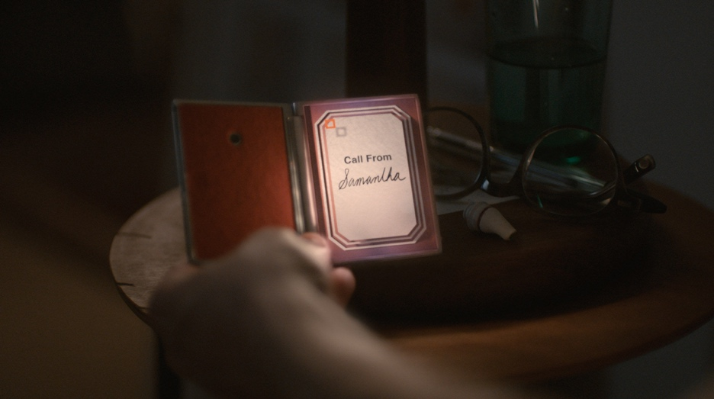
Besides Theodore’s lack of emotional capability being utilized within his relationship with technology, he interacts the most with it when it comes to sexual situations. The first time in the film we see Theodore actually look at his device is when his AI tells him sensual pregnancy photos have been released. This sparks his interest compared to his emails he was previously told about. That night we get an extensive look into his phone sex hobbies, however unusual they may be. Later in the film, he mentions to Amy, “I don’t know how to prioritize between video games and internet porn.” Before his relationship with Samantha blossoms, it is shown what type of technology user he is. Sex is a major thread throughout the film, a pivotal moment being when he and Samantha are intimate for the first time. Samantha has a liberation moment afterward; she recognizes their relationship and wants to explore more of these emotions. Theodore takes it on himself to clear the air about not wanting a committed relationship (something you normally would not have to say to your personal OS), and Samantha retorts that she did not ask for one in the first place, an answer that seemed to shock him.
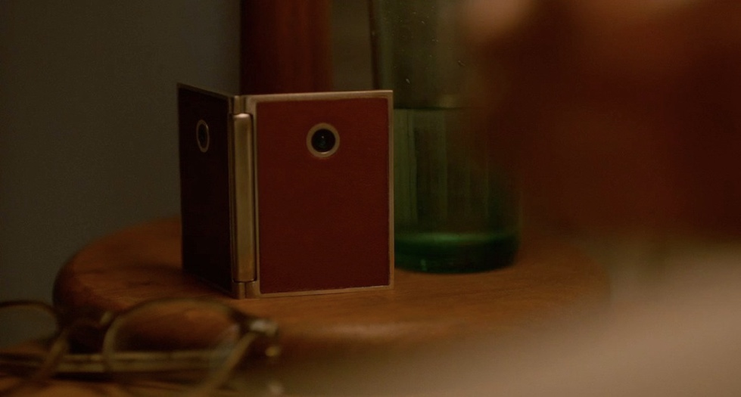
Jonze created a futuristic world in an undisclosed year that somehow feels so close yet so advanced, so modern yet so retro, so intimate yet so distant. One of the most noticeable features is the use of color in the film. There is an overall sense of red throughout the film. Red matches Theodore’s personality; he is romantic and passionate, yet the desaturation of most colors, including the warmth in their skin, reflects his loneliness, the lack of an actual, healthy love life. The camera puts us alongside Theodore, as most shots have a shallow depth of field and are close to the subject’s face. The camera forces us to be intimately close to the characters, despite the fact that the characters are not deeply intimate with audience nor each other. The physical design of the world and the new technology was intended to be subtly beautiful—Theodore wears clothes of the 1940s; the device that Samantha is in resembles a simple, elegant design of the times like a business card holder; Samantha’s OS design itself is a clean graphic, all because the focus is not projected onto these objects, it is on the relationships (or lack thereof) between the characters. Flashing technology would date whatever year would be projected; it would distract from the fact that a relationship, specifically a relationship with advanced technology, was built on dialogue, not physical looks (Hart, 2013).
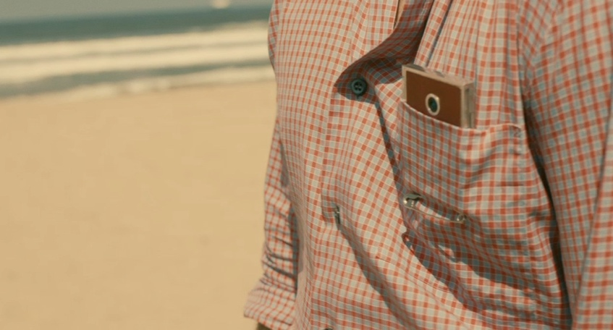
So now these men who have created this artificial woman can throw away the trivial needs of an organic female form to lust after a crafted and controlled unit. The very reason that Theodore’s relationships fall apart is that he lacks the basic skills that are required to maintain a healthy, human relationship. The idea of a man falling in love with the “perfect” woman is a very familiar trope and falling in love with the “perfect” “woman” is right behind it. In films like Blade Runner, Solaris (1972), and ex machina (2014), men all fall in love with their artificial opposite. But are they really falling in love or are they just in love with the idea of an inorganic woman versus an organic woman? Someone who does not need to be treated with human rights? Someone they can continue to push around and order? The concept takes us back to the era of the American Dream, an era where women were perfect on the outside, expected to care for the man in every sense of the word, and were abused inside the home, an era in a time like the 1940s, where the film drew (at the very least) visual inspiration from. In fact, there was a question posed to Theodore during his set up of his OS where they asked about his relationship with his mother, to which he replied that it wasn’t the best. “[Samantha]’s the perfect woman for a man without real-world emotional skills, the prototypical hook-up culture’s male, twenty years older and set in the future. She’s a personal assistant (deleting all those voicemails [Theodore]’s been too disorganized to get rid of) and a super-Mom rolled into one…” (Streep, 2013).
Both Ava from ex machina and Samantha have points where they desire to be human, to prove themselves worthy of this male attention they are receiving. Ava dresses in street clothes, covering her mechanized body parts, in order to impress the relationship that she desires with Caleb. Samantha orders the surrogate body to enhance her and Theodore’s relationship she wishes to feel. The first time she and Theodore have “sex,” she claims she is feeling him, she is moaning from the pleasure that she is feeling, despite not actually feeling any of it. This mirrors themes in Under the Skin (2013), where Scarlett Johansson’s character tries to mimic basic human interaction—eating, having sex, watching TV—in order to feel what it means to be human and despite her best efforts it does not work, much like Samantha’s desire to be physically held.
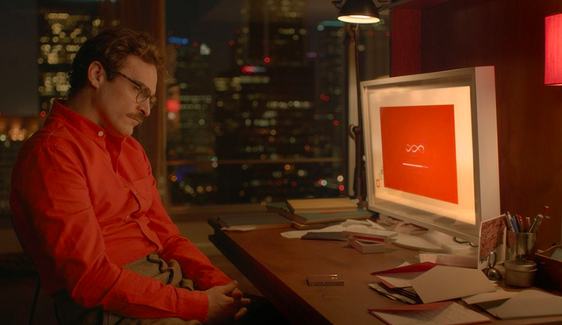
In ex machina, there is the mention of testing a chess computer. Does the computer even know what chess is? Does it know it is a computer? Then there’s a question posed later in the film: is the computer pretending to know chess? Ultimately at the end of the film, we realize that the “computer”, Ava, was pretending the entire time in order to gain agency, manipulating the very emotions that men expressed in their interactions with artificial intelligence. Men created the AI in order to control them, to be their masters, their humanistic desire to be dominant to a submissive. The turning point for a lot of these films—ex machina, Blade Runner, Her—is the idea and eventual implementation of escaping the enslavement brought on by humans, something that is common throughout the course of history and appears to continue on into the future.
The age of sentient technology is quickly coming upon us and our relationship with it can only be predicted as toxic. Her is a not-so-distant future that highlights our fixation upon technology and the utilization of the female characteristics when creating subservient systems. Our possessive infatuation with technology is, best said by Amy, “…kind of like a form of socially acceptable insanity.”

Works Cited

Addicott, J. E. (2016, January 25). A very belated analysis of Spike Jonze's "Her" (2013). Retrieved from https://jameseaddicott.wordpress.com/2016/01/25/a-very-belated-analysis-of-spike-jonzes-her-2013/
Bosker, B. (2017, December 07). SIRI RISING: The Inside Story Of Siri's Origins -- And Why She Could Overshadow The iPhone. Retrieved from https://www.huffingtonpost.com/2013/01/22/siri-do-engine-apple-iphone_n_2499165.html
Hart, H. (2013, December 18). Designing A Future Of Comfort, Color, And Gorgeous Gadgets In "Her". Retrieved from https://www.fastcompany.com/3023518/designing-a-future-of-comfort-color-and-gorgeous-gadgets-in-her
Meet the Engineers Who Created and Sold Siri to Steve Jobs. (2017, November 30). Retrieved from https://www.bigspeak.com/cheyer-kittlaus-siri-viv/
Streep, P. (2013, December 27). It's All About Him: Reflecting on Spike Jonze's "Her". Retrieved from https://www.psychologytoday.com/us/blog/tech-support/201312/it-s-all-about-him-reflecting-spike-jonze-s-her

